Title of the Contribution to be Presented in the 1st Conference on Quality Innovation and Sustainability (ICQIS2019) (Calibri 14p BOLD)

A. Author⁽¹⁾, B. Author⁽²⁾, C. Author⁽³⁾, … (Calibri 12p)

⁽¹⁾ Full address of the first Author, including e-mail. (Calibri 9p)
^{(2, 3)} List all distinct addresses in the same way. (Calibri 9p)

ABSTRACT (Calibri 10p BOLD)
This document can serve to you for preparing the full-paper of your contribution to the 7th Manufacturing Engineering Society International Conference (MESIC 2017) to be held in Vigo, Spain, on June 28th to 30th 2017. The body of the paper must be preceded by an abstract no longer than 150 words (Calibri 9p). Please, adjust left and right margins to 40 mm in ABSRACT section.
Keywords: List the keywords (max. 5 and separated by comma) covered in your paper
(THREE BLANK LINES, Calibri 10p, 6p paragraph spaced)

1. Introduction (Calibri, 11p, bold)
This document explains and demonstrates how to prepare your camera-ready manuscript for the Proceedings of the ICQIS 2019. Please, read these instructions and follow the outline of this text. The length of your paper must not be longer than 8 pages (210 x 297 mm, A4 format, upper and lower margins 25 mm-left and right margins 30 mm). Please, use this document as a template for writing your full paper. Moreover, the title of your contribution must be in Calibri-bold 14p, followed by authors’ names (12p) and addresses (9p). An abstract no longer than 150 words, with a list of keywords (Calibri 8p), must precede the body of the text.
The text (Calibri 10p, single line spaced, 6p paragraph spaced) will be written at single column and it must include: main objectives, results and conclusions of the research work to be presented in the Conference. It must be written in English.
It is highly recommendable to prepare an introduction section in order to show the objectives and, if necessary, the antecedents [1] of the research with the corresponding references [2,3], which will be indicated by squared brackets [1-3] and placed in the final section. No line spacing must be placed between references (see section 6).
Please send the paper to the e-mail address: carlos_sa@esce.ipvc.pt, in file format Word 97 or higher.
Contributions will be peer reviewed by members of the International Scientific Committee in order to guarantee the level and quality of the presented papers. Moreover, it must be taken into account that extended versions of selected papers will be published in special issues of international journals indexed.

2. Sections and Subsections
The head of each section must be written in Calibri 11p bold, and it must be numbered in the form that is indicated in this document. Sections and subsections must be separated by a blank line.

2.1 Subsections (Calibri 10p, underline)
Subsections must be numerated by a second identification number after the number of the main section. The title of the subsection must be written in Calibri 10p underline.
2.2 Subsections
Please, include subsections only if necessary in order to facilitate the best understanding of your paper. No spacing lines must be introduced between subsections.

3. Tables and Figures
The obtained results will be shown and discussed using, if necessary, Tables and/or Figures.
Tables will be referred using Table I, Table II, … and they will placed as it can be seen in the example, Table I.
Table I. Heading of table. Example (Calibri 10p cursive)
Sample | Nominal (mm) | Mean (mm)
X | 225.855 | 225.842
Y | 345.679 | 345.668
Z | 50.383 | 50.382

On the other hand, Figures will be referred using Figure 1, Figure 2,… and they will inserted as it can be seen in the example, Figure 1.
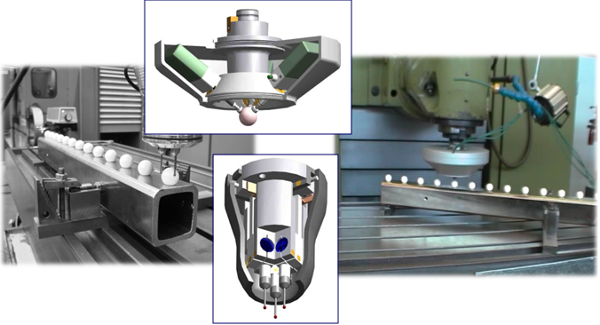
Figure 1. Example of a figure inserted in the paper (Calibri 10p cursive)

4. Conclusions
Please, summarise the main conclusions and original contributions of your work. If you follow these instructions you will facilitate the peer review process of your paper.

5. Acknowledgements
It is permitted to include an acknowledgements section.

6. References
[1] W. Yousfi, R. Laheurte, P. Darnis, O. Cahuc. 3D modelling of kinematic fields in the cutting area: application to milling. The International Journal of Advanced Quality Control Technology, 86, 9-12, 2735–2745, 2016.
[2] A.H. Slocum. Precision Machine Design. Prentice-Hall, Society of Quality Control Engineers Dearborn (MI), USA, 2016.
[3] A. Brau, J. Santolaria, I. Asensio, J. J. Aguilar. Mechanical design of an indexed metrology platform for verification of portable Coordinate Measuring Machines. Proceedings of 5th Lean Conference (LEAN 2018). Zaragoza, Spain, 2013.

